Tutorial on Hardware Debugging Using Curiosity Standard Board (DM164137)

Objective:
This tutorial demonstrates hardware debugging through Project #4 – Analog Input/Output in In 10 Lines of Code by Lucio Di Jasio. This project uses the on-board potentiometer to control the brightness of LEDs using the ADC and PWM peripherals.

Procedures:
- Connect the Curiosity Standard Board to the computer through a USB cable.

- Open MPLAP X IDE and create New Project. Select “Standalone Project”.
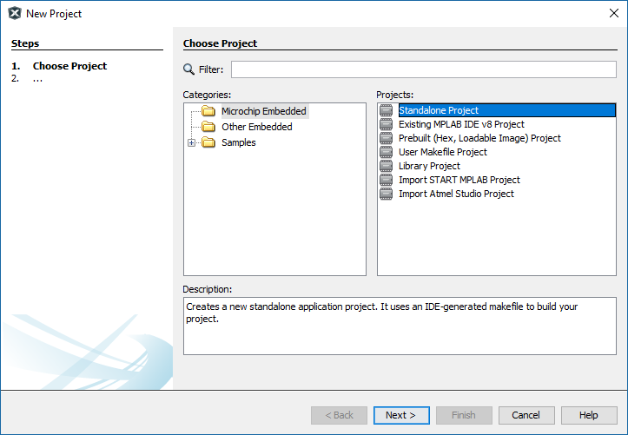

- Select Device. Select “PIC16F1619” under “Mid-Range 8-bit MCUs” device family.
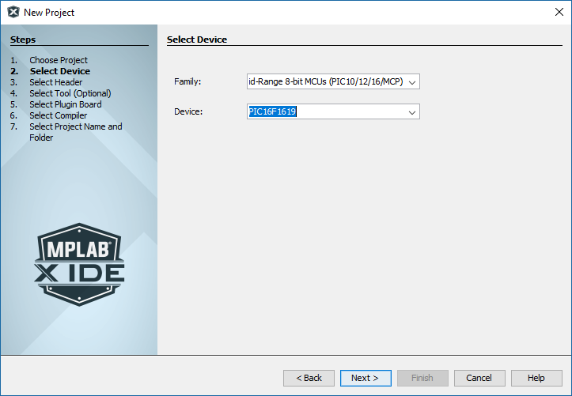

- Select Header. Select “None”. No debug header is used in this tutorial.
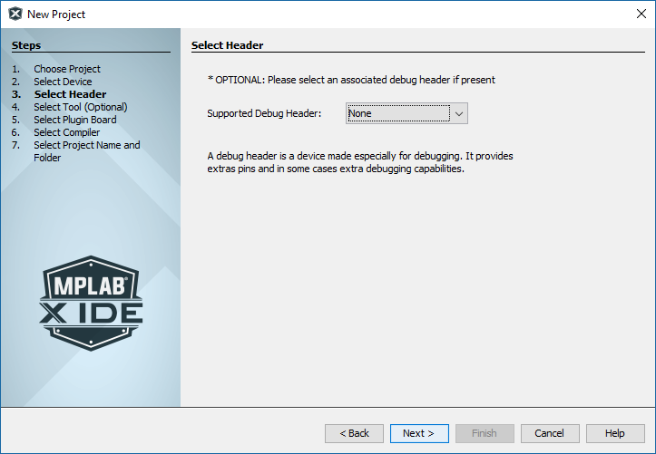
- Select Tool. Select “Curiosity” under “Microchip Kits” -> “Starter Kits”. Hover the mouse pointer over the name “Curiosity” to reveal the Board’s serial number.
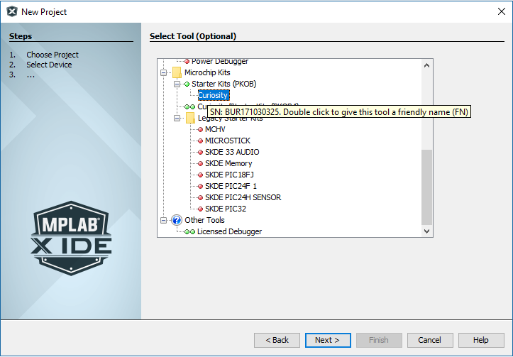

- Select Compiler. XC8 (v2.05) is used in this tutorial.
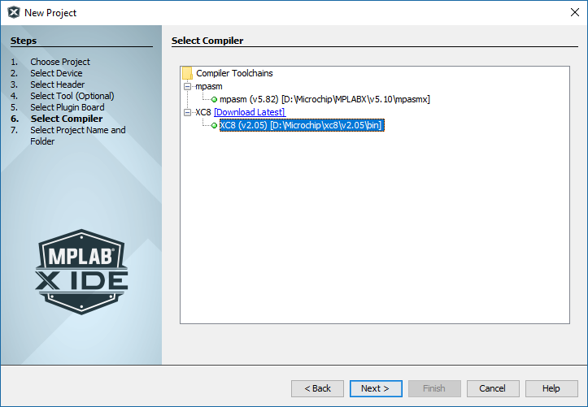
- Select Project Name and Folder. “Demo1” is used as project name in this tutorial. Then click “Finish”.
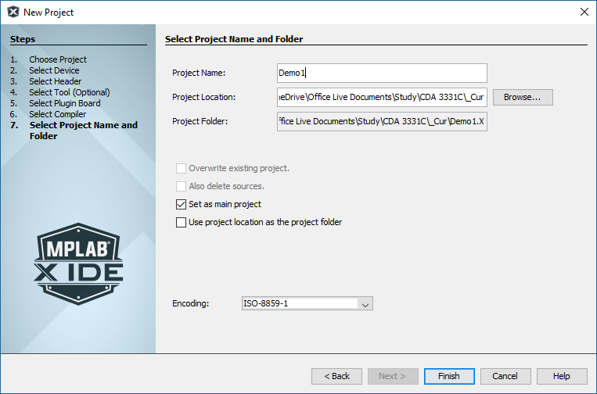

- .Open MCC and add PWM3, TMR2 and ADC peripherals by double-clicking these peripherals under Device Resources.
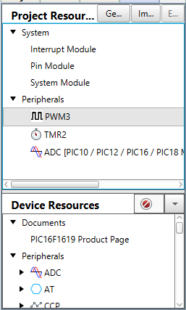
- Set PWM3 as shown. The C code will change the duty cycle so any value would work.
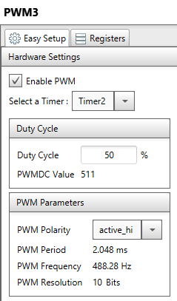

- Set TMR2 as shown. These should be default settings.
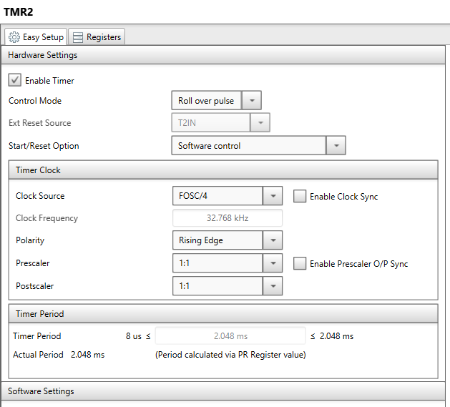
- Set ADC as shown. These should be default settings. Make sure the result alignment is “right”.
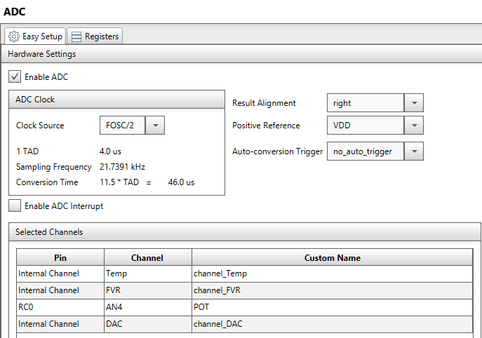

- Set Pin Module and assign pins as shown:
- Potentiometer is at RC0 (analog input pin)
- LEDs are at RA1, RA2, RA5 and RC5 (output pins)
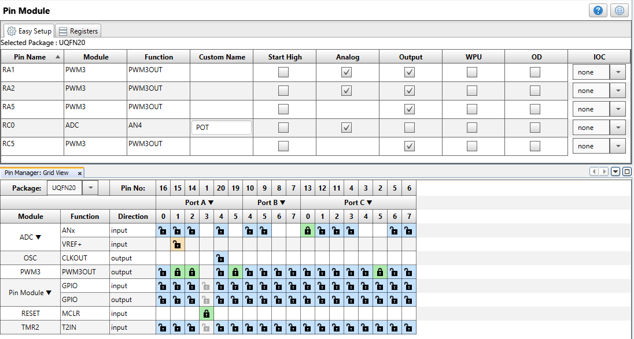
- Click the “Generate” button under Project Resources for MCC to generate the source files.

- Include the following code within the main() function in the main.c file, as shown:
adc_result_t ADC_Grab;

while (1)
{
ADC_Grab = ADC_GetConversion(POT);
PWM3_LoadDutyValue(ADC_Grab);
}
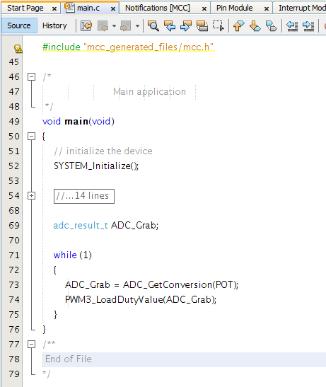
- Add a breakpoint at the return statement of the ADC_GetConversion() function in the adc.c file by clicking on the line number on the left.
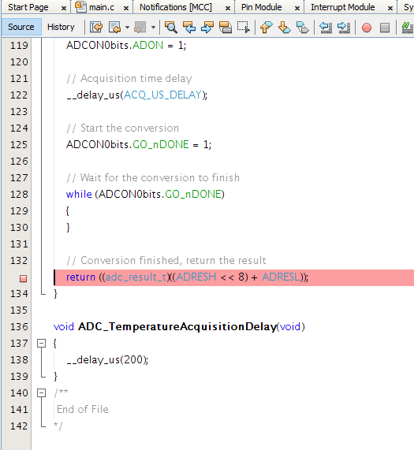

- Click “Debug Project” icon on the toolbar. MPLAB X IDE will program the Curiosity Standard Board for debugging.
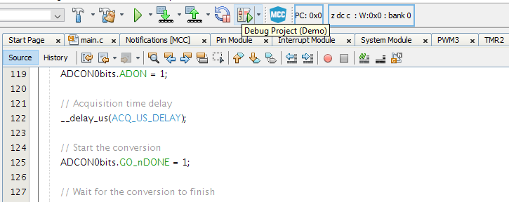
- Open the “Variables” and “Disassembly” windows from the Window -> Debugging menu if these windows do not open automatically. Open additional debugging windows as needed.
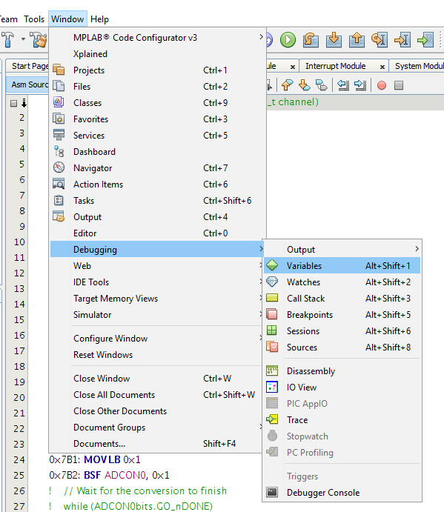
- Add new watches under the “Variables” window. For this tutorial, the LATA, PWM3DCH, PWM3DCL, ADRES, ADRESH, ADRESL and ADCON0 registers are added.
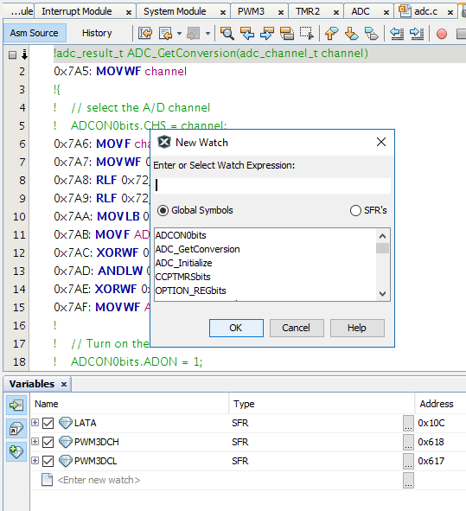
- Click “Step Into” icon (or F7) from the toolbar for step-by-step hardware debugging, or “Continue” (or F5) to run to the breakpoint. Turn the potentiometer to a different position and observe the changes in various registers during debugging.

Tip: click “Continue” (or F5) to skip over the following lines in the ADC_GetConversion() function since ADC conversion cannot complete in the debugging mode.
// Wait for the conversion to finish
while (ADCON0bits.GO_nDONE)
{
}
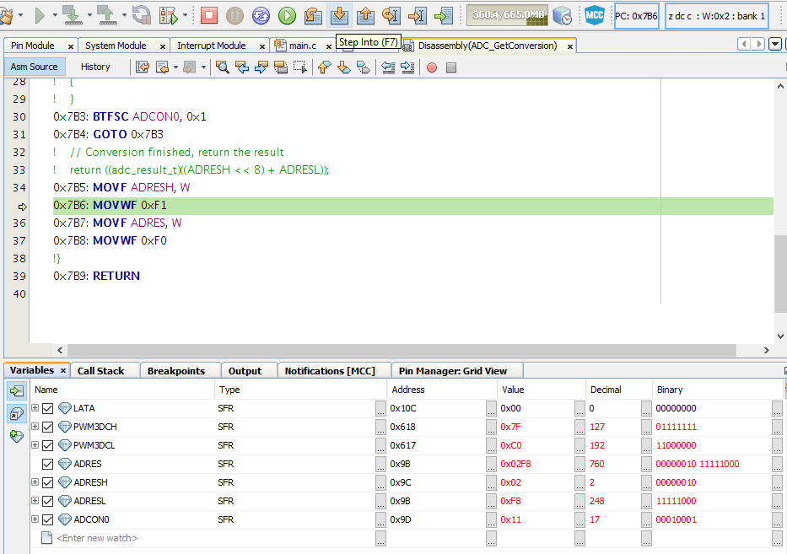

Reference Materials:
- PIC16F1619 Data Sheet: http://ww1.microchip.com/downloads/en/DeviceDoc/40001770D.pdf
- Curiosity Board User Guide: http://ww1.microchip.com/downloads/en/DeviceDoc/40001804B.pdf
- Curiosity Board Quick Start Guide: http://ww1.microchip.com/downloads/en/DeviceDoc/40001791A.pdf

